**FORBIDDEN PATHS :**

* It is given we can’t use absolute file paths.
* But the path to the flag is given in the question.
* Therefore we must access each directory

separately as it is given in the question.

* The command to access parent directories of the
* cwd is ../
* Its given that we have to climb up 4 directories to

get to the flag.

The following command is given in the text box:



And we get our flag :

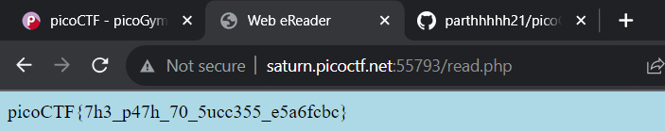

FLAG :

picoCTF{7h3_p47h_70_5ucc355_e5a6fcbc}